UNIVERSITY OF WAH (UOW)

DEPARTMENT OF COMPUTER SCIENCE



BSCS 3RD B

REG #: UW-24-CS-BS-088

SUBMITTED BY: SAADI SAFDAR

SUBMITTED TO: Ms. MUNNIBA KHAN

COURSE TITLE: DATA STRUCTURES

COURSE CODE: CS – 201 L

LAB MANUAL

TASK 1
Write C++ code for the following:
1. Declare the variables int quantity, float price, and totalBill for the inventory section.
2. Take input from the user for quantity and price, compute the total bill using totalBill =
quantity * price, and display the result.
3. Using two sample integer values, perform and display addition, subtraction,
multiplication, division, and modulus.

#include <iostream>
using namespace std;
int main()
{
int quantitiy;
float price;
float totalBill;

cout<<"Enter quantity: ";
cin>>quantitiy;
cout<<"\nEnter price: ";
cin>>price;

totalBill = quantitiy * price;

cout<< "The total bill is: "<<totalBill;
}

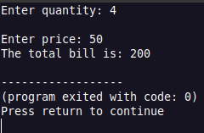

#include <iostream>
using namespace std;

int main() {
int a, b;

cout << "Enter two numbers: ";
cin >> a >> b;

cout << "Sum: " << a + b << endl;
cout << "Difference: " << a - b << endl;
cout << "Product: " << a * b << endl;
cout << "Quotient: " << a / b << endl;
cout << "Remainder: " << a % b << endl;
}

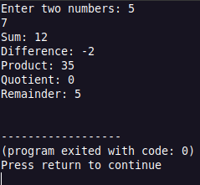

Write C++ code for the following:
1. Input marks of a student and display the grade using if-else or switch-case.
2. Use a for loop to print numbers from 1 to 10.
3. Use a while loop to calculate and display the sum of numbers from 1 to N, where N is
entered by the user.
4. Use a do-while loop to display the multiplication table of a number entered by the user.

#include <iostream>
using namespace std;

int main() {

int marks;
cout << "Enter a marks of student: ";
cin >> marks;
if(marks > 90){
cout<<"Grade A+";
}
else if (marks > 80){
cout<<"Grade A";
}
else if (marks > 70){
cout<<"Grade B";
}
else if (marks > 60){
cout<<"Grade c";
}
else if (marks > 50){
cout<<"Grade D";
}
else{
cout<<"Grade F";
}

int num;
cout << "\n\nEnter a number: ";
cin >> num;

cout << "\nUsing for loop:\n";
for (int i = 1; i <= 10; i++) {
cout << i << endl;
}

cout << "Using while loop:\n";
int i = 1;
int sum = 0;
while (i <= 10) {
sum = num + i;
i++;
}
cout << sum << endl;

cout << "Using do-while loop:\n";
i = 1;
do {
cout << num << " x " << i << " = " << num * i << endl;
i++;
} while (i <= 10);

return 0;
}

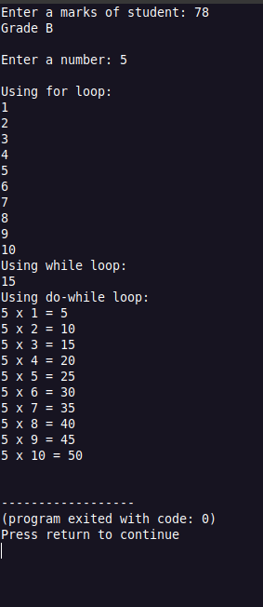

TASK 2

Array Operations & Search
Consider the array below representing stock quantities:
int stock[10] = {5, 15, 22, 35, 40, 55, 65, 70, 85, 95};
Write C++ code for the following:
1. Implement linear search to find a specific quantity.
2. Insert a new quantity at a specific position in the array.
3. Delete an element from a given position in the array.
4. Find and display the maximum and minimum quantity in the updated array.
5. Display the total size of the array using sizeof().

#include <iostream>
using namespace std;

int main() {

int stock[10] = {5, 15, 22, 35, 40, 55, 65, 70, 85, 95};
int size = 10;
int num;
int pos;

cout << "Enter an element to search: ";
cin >> num;
bool found = false;

for (int i = 0; i < size; ++i)
if (stock[i] == num)
{
cout<<"Element found at position: "<<i<<endl;
found = true;
break;
}

if(!found)
{
cout<<"Element not found."<<endl;
}

cout << "Enter the element to insert : ";
cin >> num;

for( int i=size; i>pos-1; i--)
{
stock[i]=stock[i+1];
}

size++;

cout<<"Enter position of element to delete: ";
cin>>pos;

for(int i=pos; i<size-1; i++)
if(i!=pos)
{
stock[i] = stock[i + 1];
}

size--;

int hv, lv;
hv = stock[0];
lv = stock[0];

for (int j=0; j<size-1; j++)
if(stock[j]>hv)
{
hv = stock[j];
}

cout<<"Highest value is: "<<hv<<endl;
cout<<"\nLowest value is: "<<lv<<endl;

cout << " The size of array is: "<< sizeof(stock) ;

return 0;
}

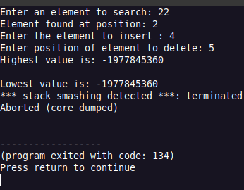

TASK 3
2D Arrays & Structures
Student
Marks in 3 Subjects
Student1 [80, 85, 78]
Student2 [88, 82, 90]
Student3 [75, 89, 84]
Write a C++ program to:
- Declare a 2D array for student marks.
- Display the marks in matrix form.
- Use pointer variables and the & operator to display addresses.
- Create a structure Student with name, roll, and marks.
- Input details for an array of three Student structures.
- Sort the students in ascending order of marks.
- Display the sorted list of students clearly.

Task 4
Singly Linked List
Write a C++ program to:
1. Create a singly linked list to store names.
2. Implement insertion at:
oThe beginning of the list
oThe end of the list
oA specific position in the list
3. Traverse and display all names in the list.

#include <iostream>
using namespace std;

struct Node {
int data;
Node* next;
};

class LinkedList {
private:
Node* head;
Node* tail;

public:
LinkedList() {
head = NULL;
tail = NULL;
}

Node* createNode(int value) {
Node* temp = new Node;
if (temp == NULL) {
cout << "Memory not allocated!" << endl;
return NULL;
}
temp->data = value;
temp->next = NULL;
return temp;
}

void insertBegin(int value) {
Node* temp = createNode(value);
if (head == NULL) {
head = tail = temp;
} else {
temp->next = head;
head = temp;
}
cout << "Inserted " << value << " at beginning.\n";
}

void insertLast(int value) {
Node* temp = createNode(value);
if (head == NULL) {
head = tail = temp;
} else {
tail->next = temp;
tail = temp;
}
cout << "Inserted " << value << " at end.\n";
}

void insertPos(int value, int pos) {
Node* temp = createNode(value);
if (pos < 1) {
cout << "Position should be >= 1\n";
return;
}
if (pos == 1) {
temp->next = head;
head = temp;
if (tail == NULL) tail = temp;
cout << "Inserted " << value << " at position " << pos << endl;
return;
}
Node* current = head;
for (int i = 1; i < pos - 1; i++) {
if (current == NULL) {
cout << "Position out of range\n";
return;
}
current = current->next;
}
if (current == NULL) {
cout << "Position out of range\n";
return;
}
temp->next = current->next;
current->next = temp;
if (temp->next == NULL) tail = temp;
cout << "Inserted " << value << " at position " << pos << endl;
}

void searchElement(int value) {
Node* current = head;
int pos = 1;
bool found = false;
while (current != NULL) {
if (current->data == value) {
cout << "Element " << value << " found at position " << pos << endl;
found = true;
break;
}
current = current->next;
pos++;
}
if (!found) cout << "Element " << value << " not found\n";
}

void display() {
if (head == NULL) {
cout << "List is empty\n";
return;
}
Node* current = head;
cout << "Linked List: ";
while (current != NULL) {
cout << current->data << " -> ";
current = current->next;
}
cout << "NULL\n";
}

int main() {
LinkedList list;
int choice, value, pos;

do {
cout << "1. Insert at Beginning\n";
cout << "2. Insert at End\n";
cout << "3. Insert at Position\n";
cout << "4. Display List\n";
cout << "10. Exit\n";
cout << "Enter your choice: ";
cin >> choice;

switch (choice) {
case 1:
cout << "Enter value: ";
cin >> value;
list.insertBegin(value);
break;
case 2:
cout << "Enter value: ";
cin >> value;
list.insertLast(value);
break;
case 3:
cout << "Enter value: ";
cin >> value;
cout << "Enter position: ";
cin >> pos;
list.insertPos(value, pos);
break;
case 4:
list.display();
case 5:
cout << "Exiting...\n";
break;
default:
cout << "Invalid choice!\n";
}
} while (choice != 5);

return 0;
}

